Create the database:

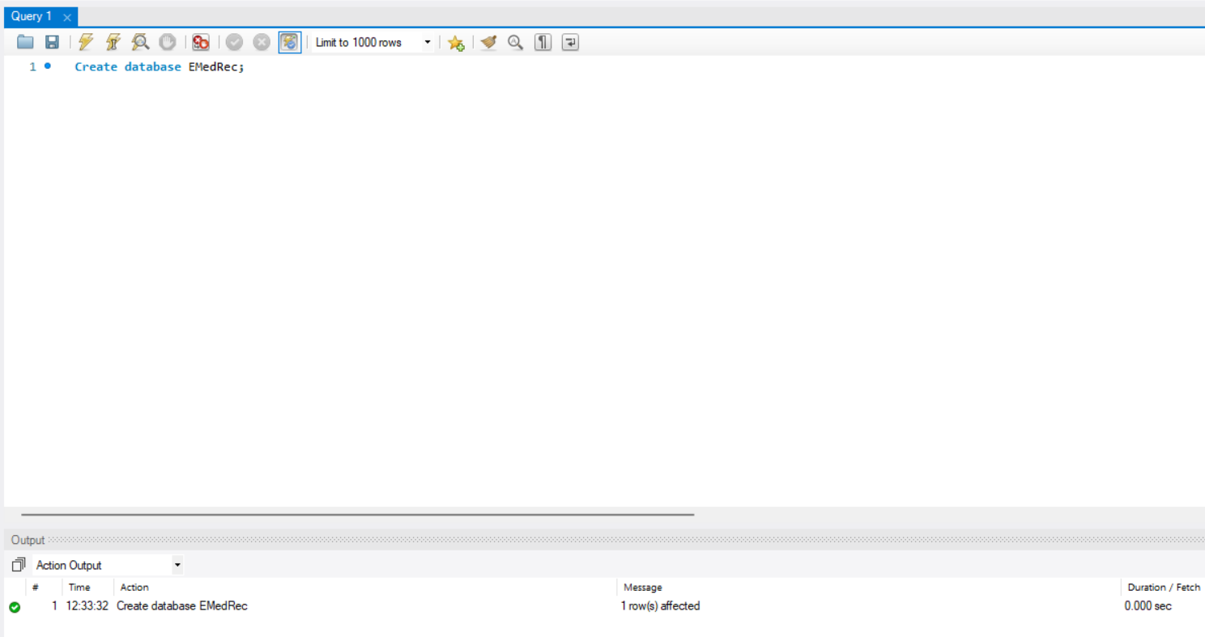

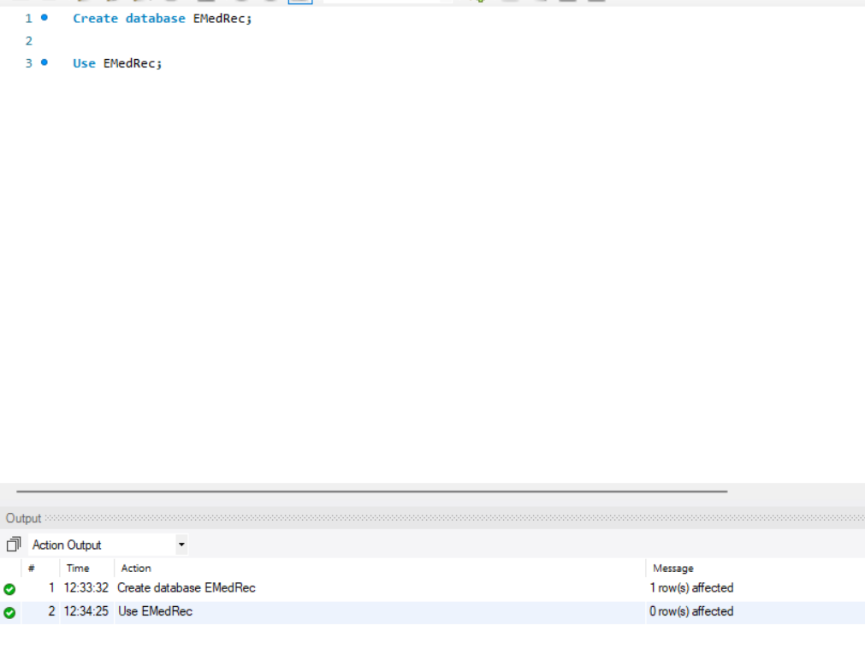

Patient table creation:

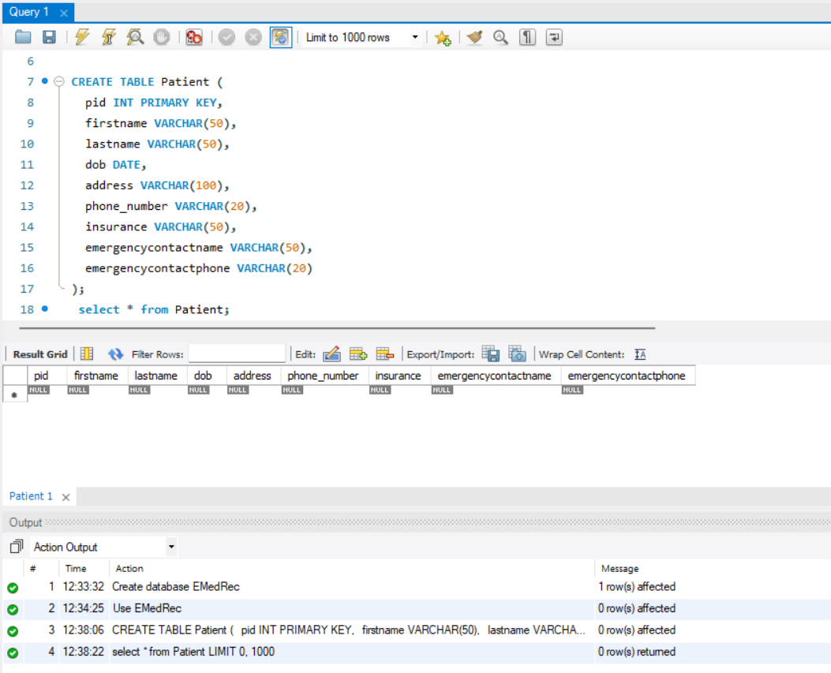

Provider table creation:

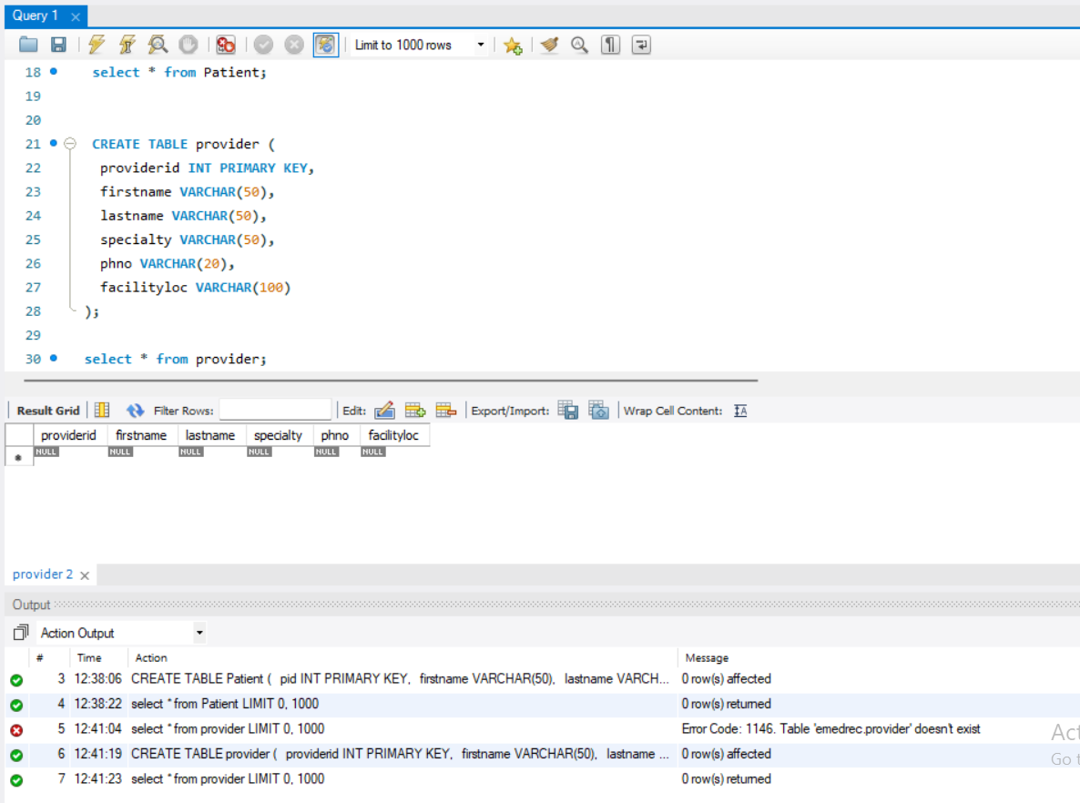

Visit table creation:

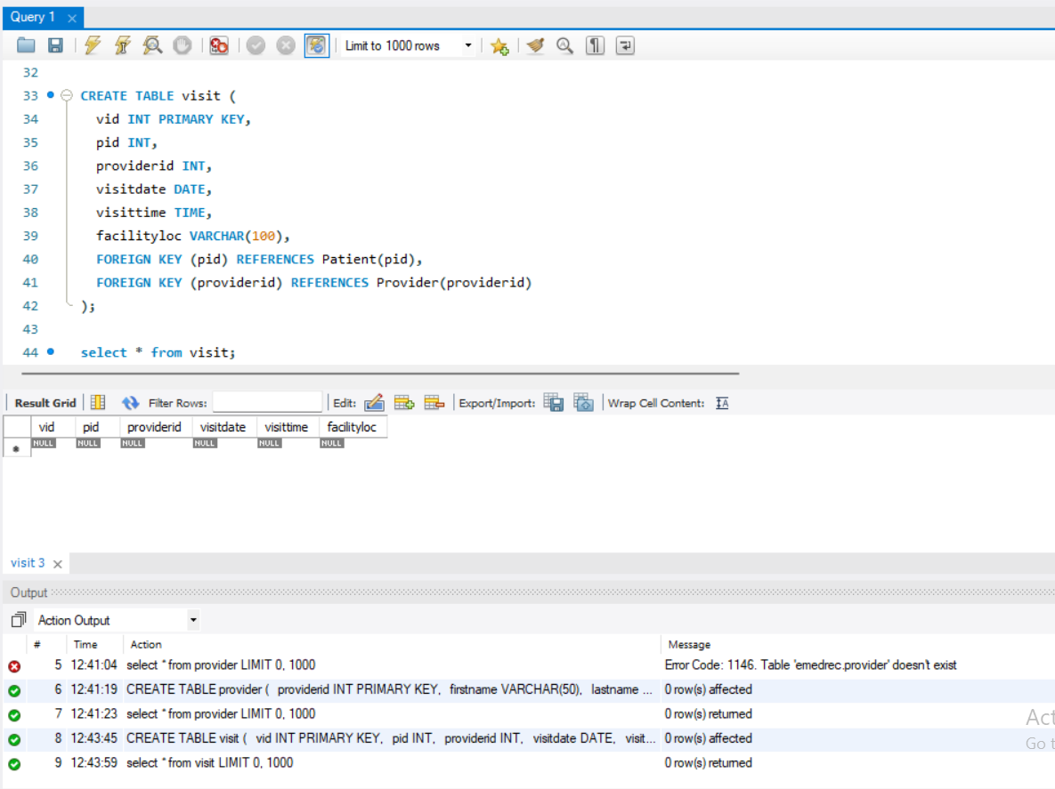

Clinical care table creation:

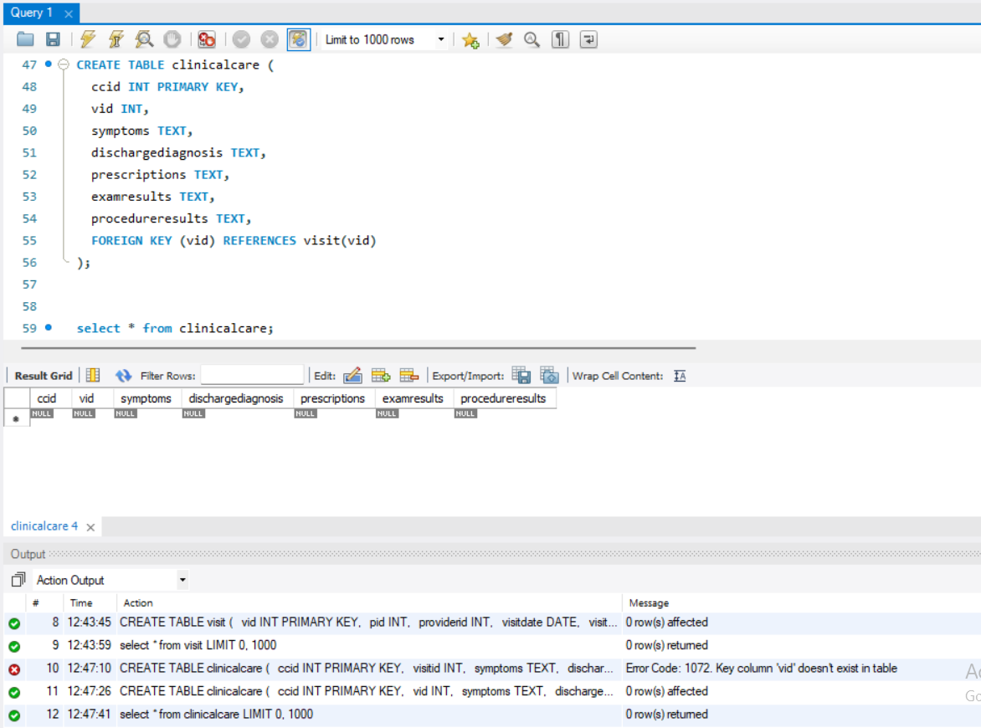

Appointment table creation: 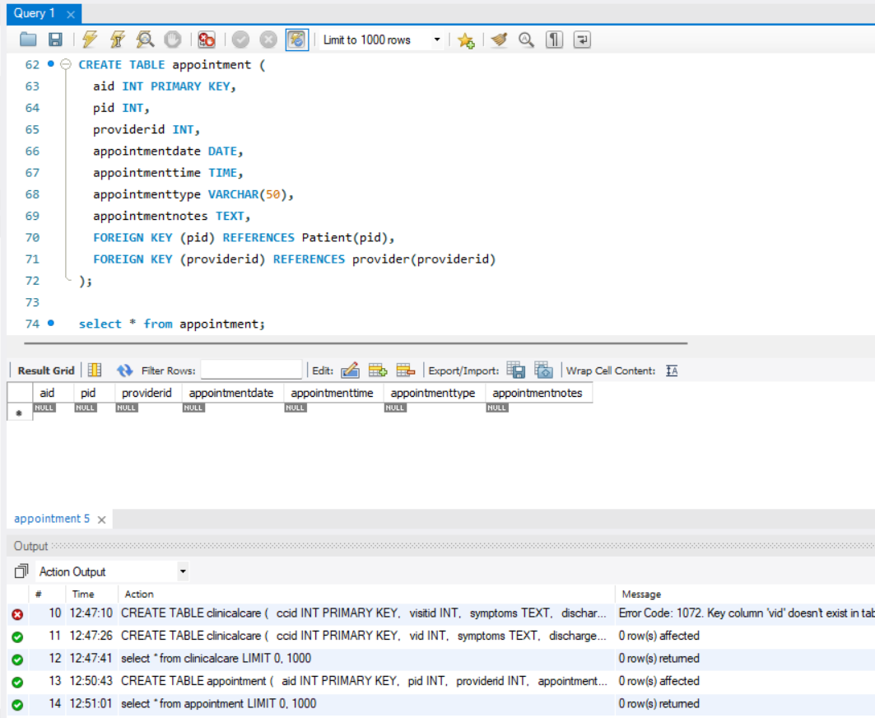

Examroom table creation:

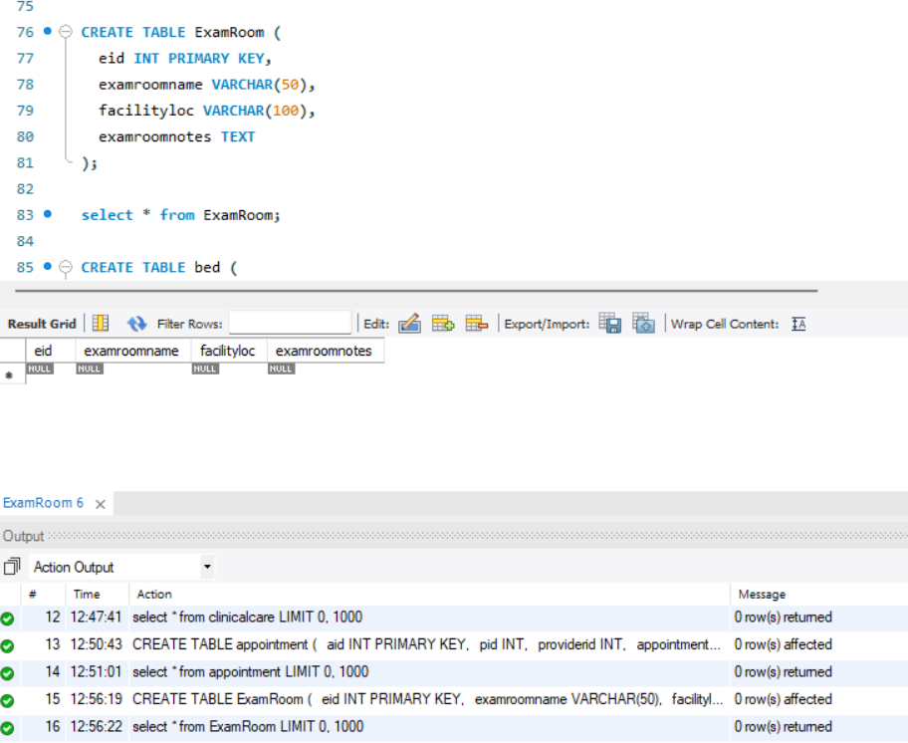

Bed table creation:

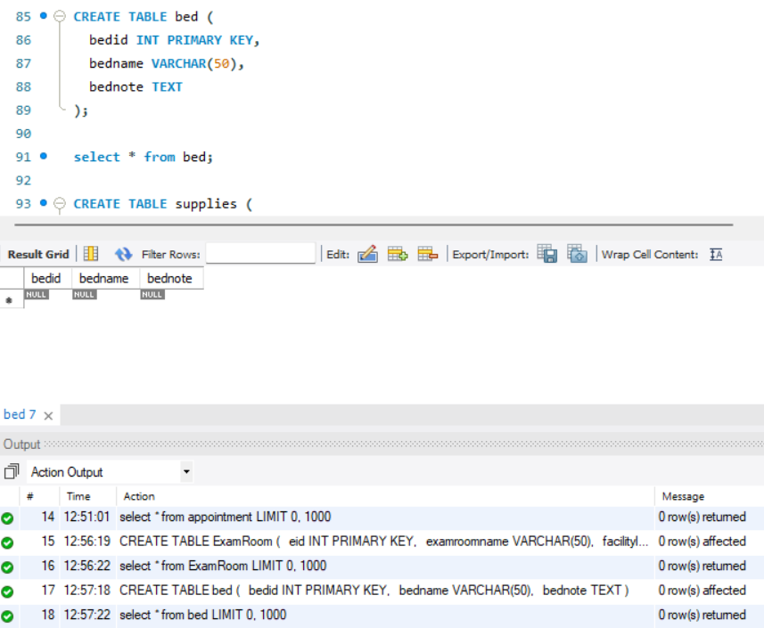

Supplies table creation:

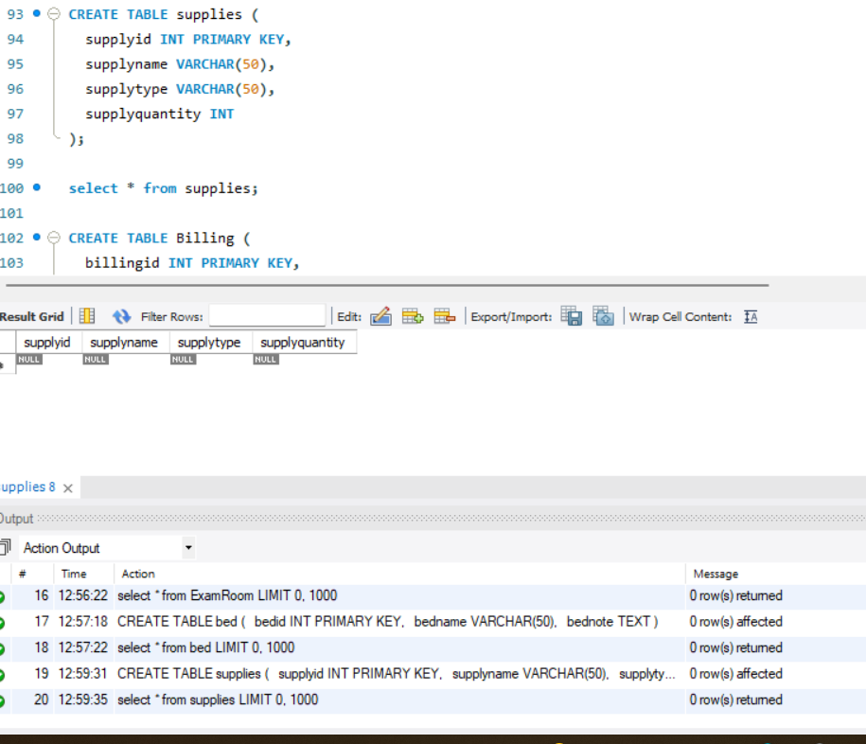

billing table created:

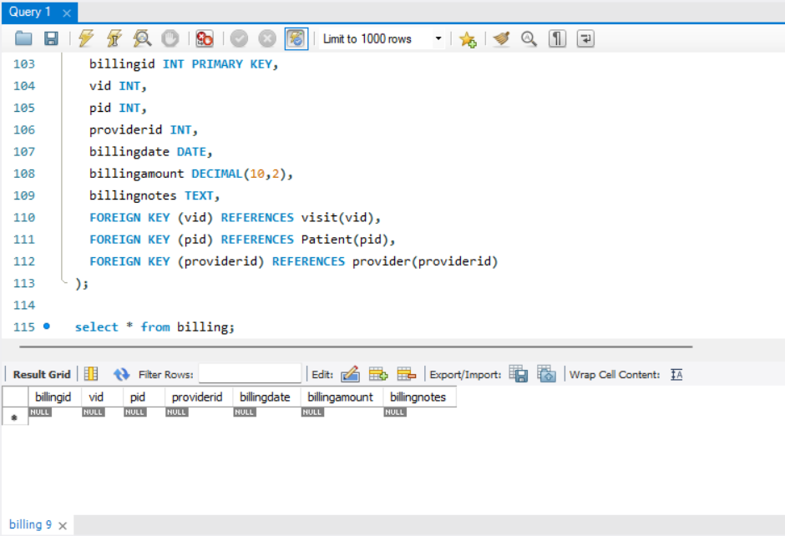

Patient test data:

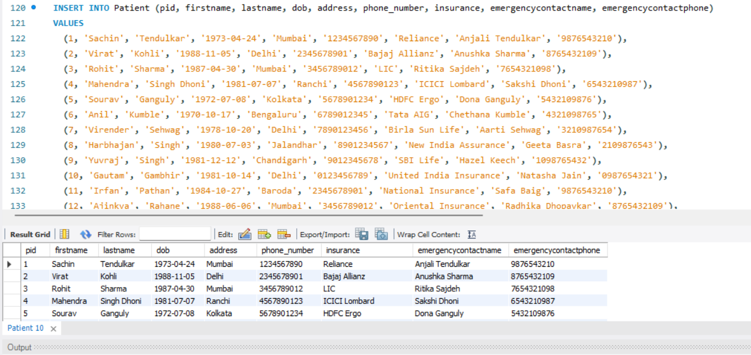

Provider test data:

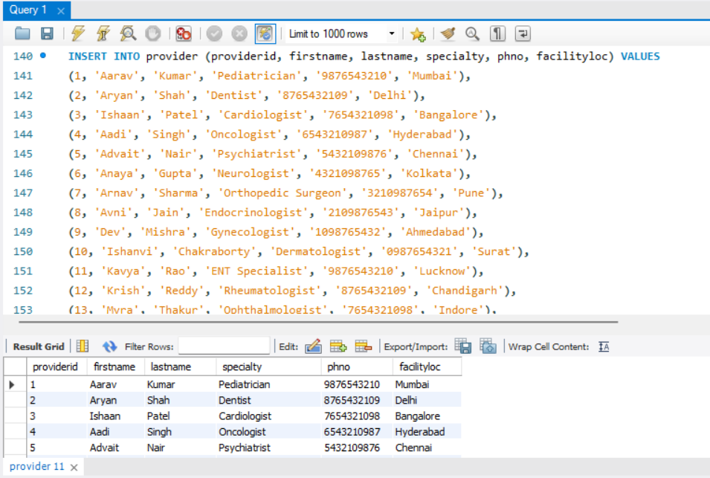

Visit test data:

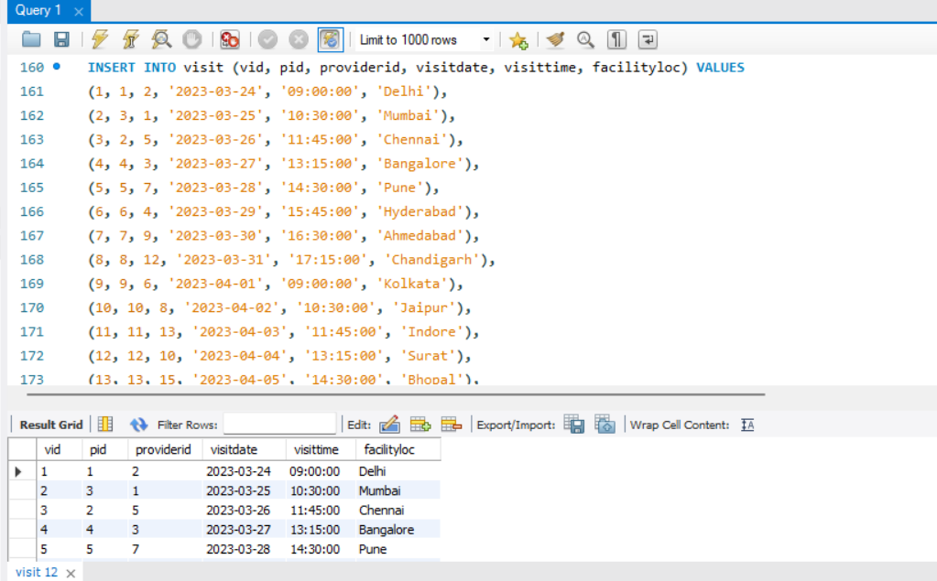

Clinical-care test data:

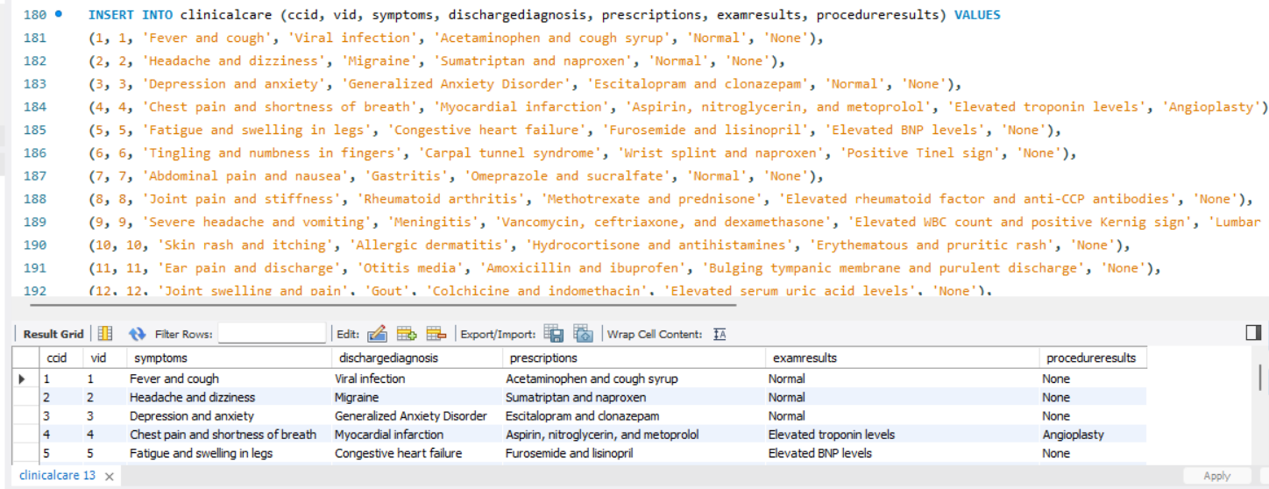

Appointment test data:

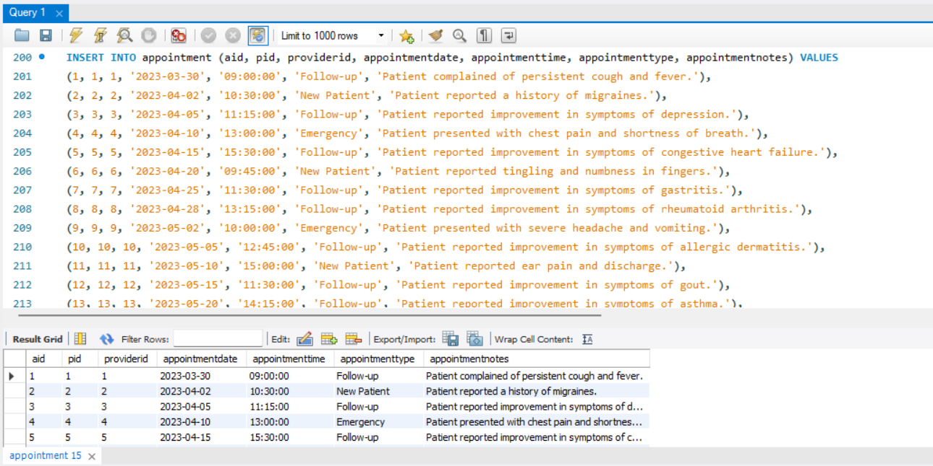

Examroom test data: 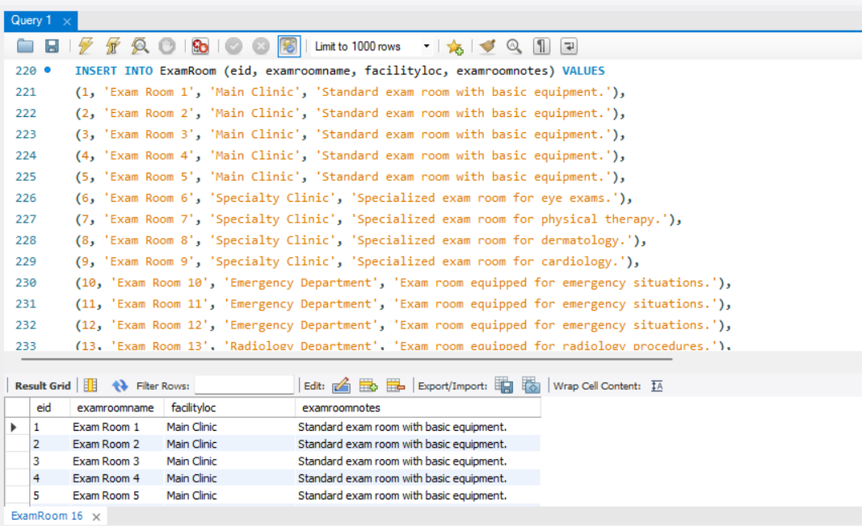

Bed test data:

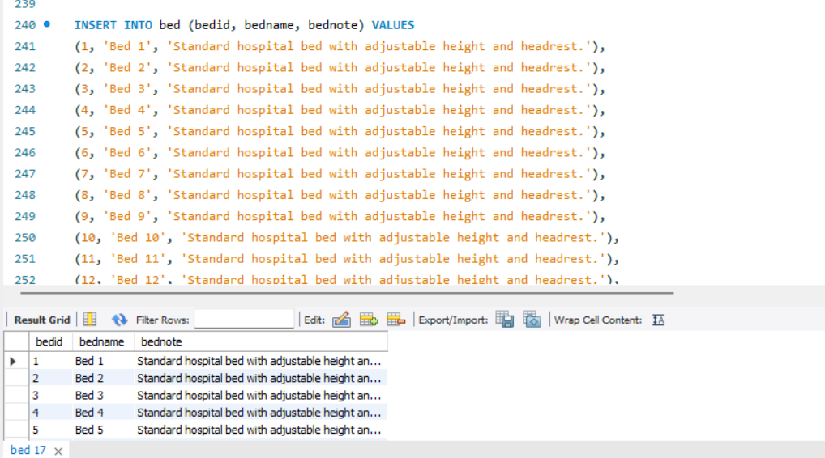

Supplies test data:

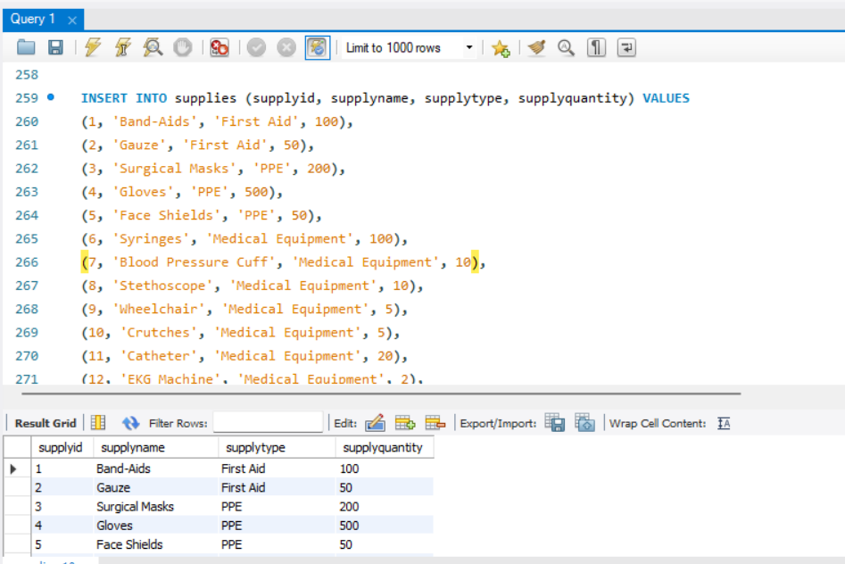

Billing test data:

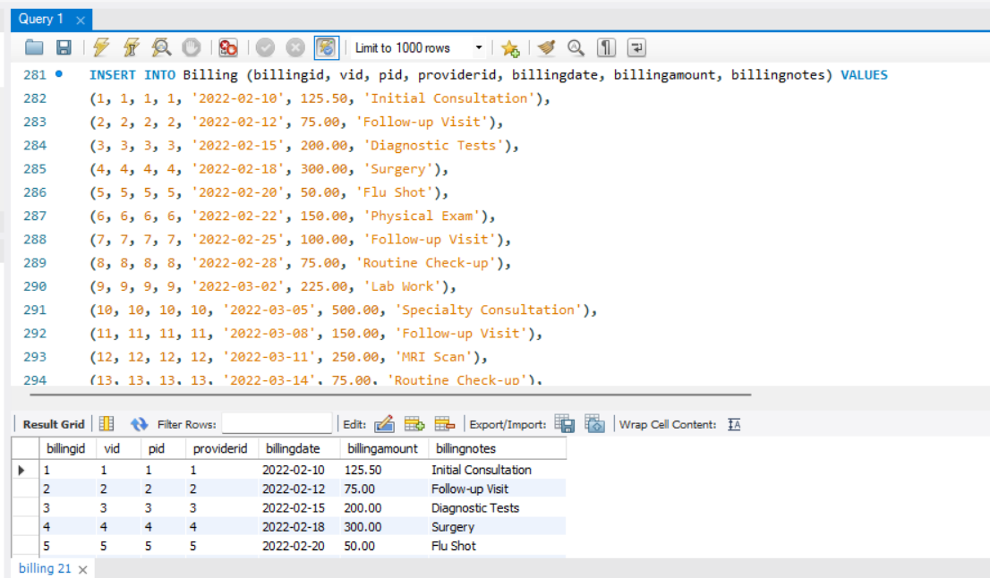

**Q) Your database should support editing of existing records to correct data entry mistakes or legitimate changes of information (e.g. change of address or insurance).**

Executed update command:

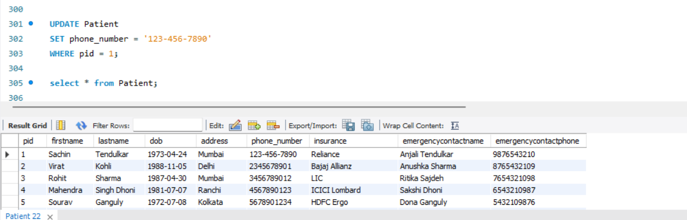

Executed select command:

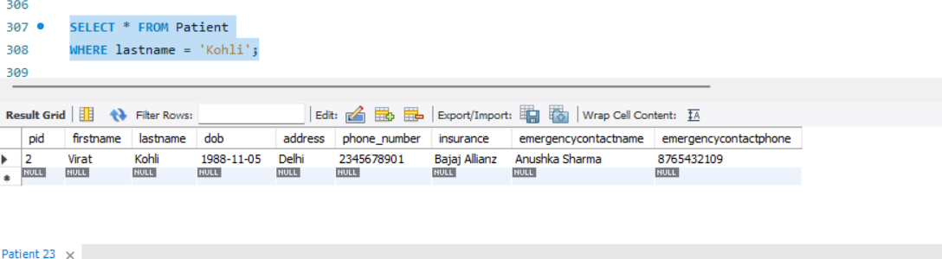

Executed update command:

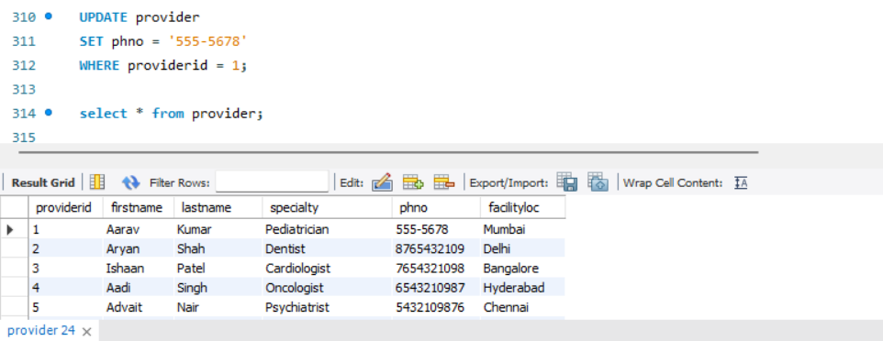

Executed Insert command:

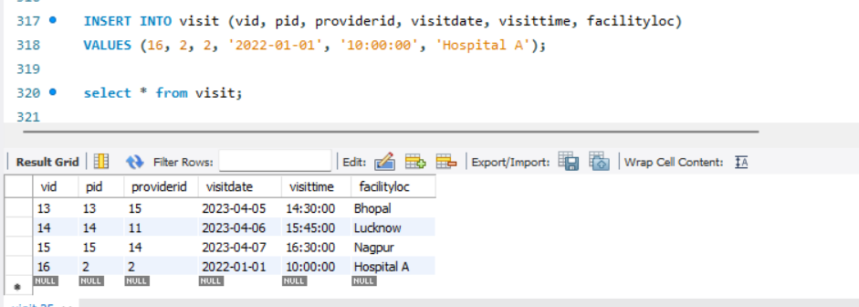

Executed Update command:

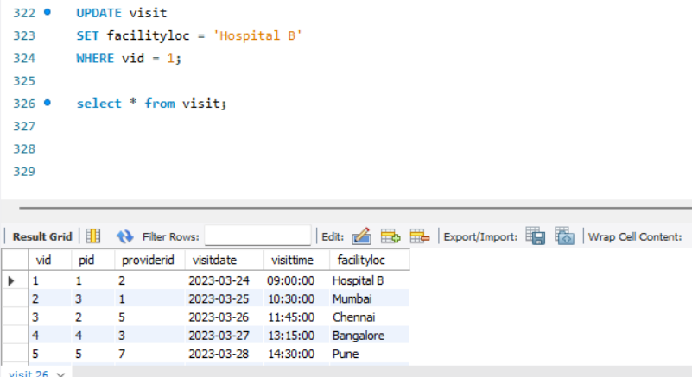

Executed the Update command:

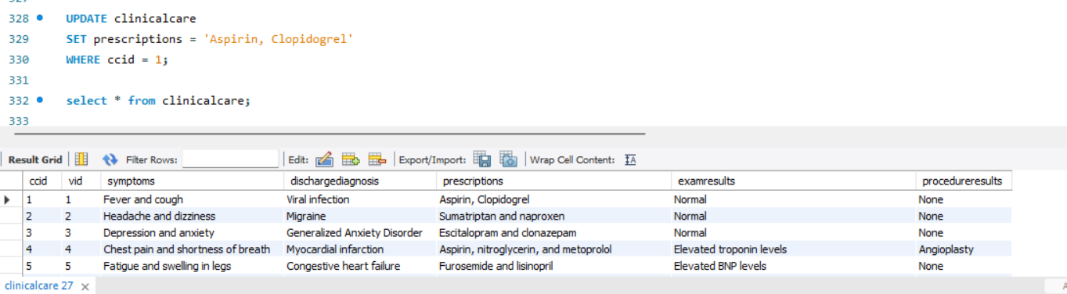

Executed the Select command:

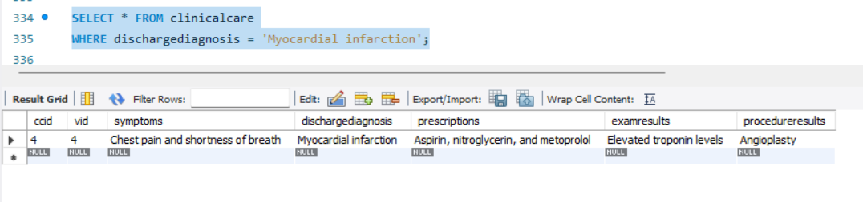

**Q) Your database should support searching of patient records based on name, ID, and possibly other information such as visit dates.**

Search terms:

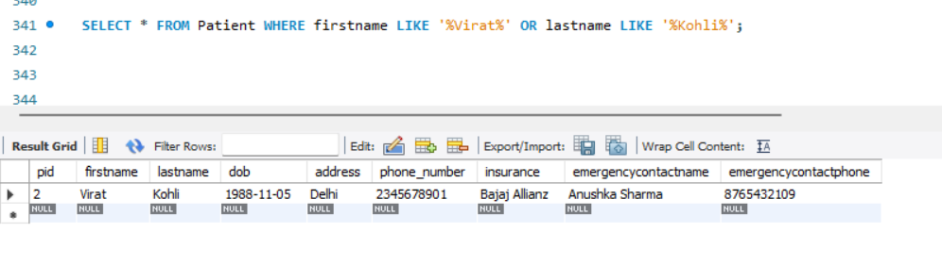

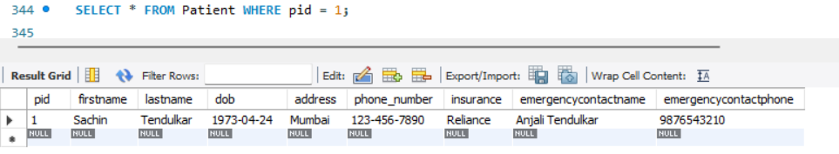

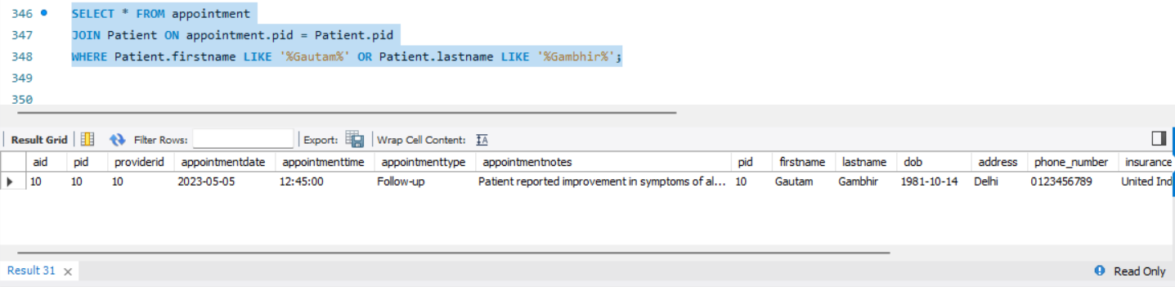

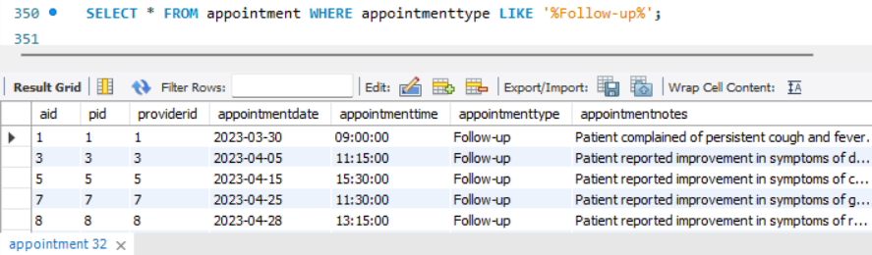

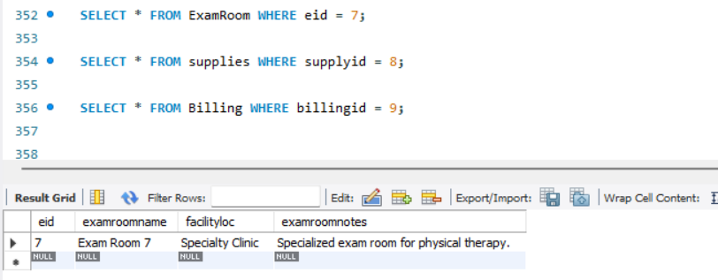

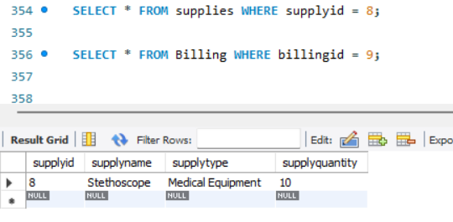

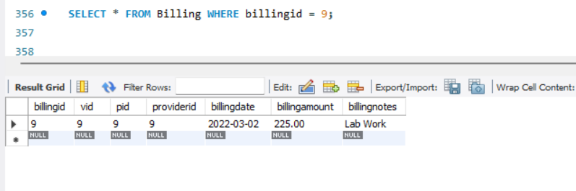

**Q) Your database should support reporting functions such as listing of all patients who satisfy certain selection criteria, such as those who have been given certain diagnosis, or who visited on certain days, or who have been seen by certain doctor, or combinations of these Such as, the diagnoses of patients who visited the clinic twice within the shortest time interval.**

